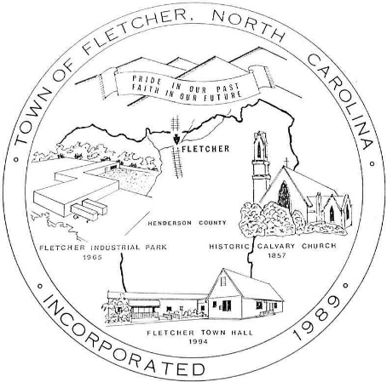
Land Development Code
Town of Fletcher, NC

“Pride in Our Past, Faith in our Future”

Adoption Date: 11.14.2005
Effective Date: 03.6.2006
As Amended: 05.11.2026

